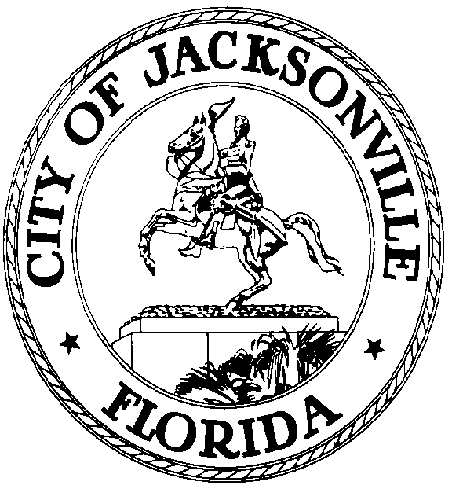

GARRETT L. DENNIS
Council Member District 9
Email: GarrettD@coj.net

OFFICE OF THE CITY COUNCIL
117 West Duval Street City Hall, Suite 425
Jacksonville, Florida 32202
Office (904) 255-5209
Fax (904) 255-5230
.

HYBRID VIRTUAL IN-PERSON NOTICE MEETING
JANUARY 6, 2021
(4:30 PM)

HYBRID VIRTUAL IN-PERSON NOTICE MEETING
SPECIAL COMMITTEE ON REDISTRICTING - CM GARRETT DENNIS, CHAIR
JANUARY 14, 2021 (8:00 AM – 8:30 AM)

MEETING TIME: 8:00 AM – 8:30 AM
Physical Location: Council Chambers
City Hall
117 W. Duval Street
Jacksonville, Florida 32202

(If attending virtually, please join the meeting by 7:50 AM)
Meeting ID: 997 2238 9119
Passcode: 227994

Notice is hereby given that the Honorable Garrett Dennis, Chair of the Special Committee on Redistricting, hereby schedules a HYBRID VIRTUAL IN-PERSON NOTICED MEETING for Thursday, January 14, 2021, 8:00 AM – 8:30 AM, 117 West Duval Street, Council Chambers, - Jacksonville, Florida. The purpose of the meeting is to discuss organizational planning and any other items noted on the meeting's agenda or at the Chair's discretion.

The Committee Members (3) quorum will need to be present in person, but other members may attend utilizing Communications Media Technology (CMT).

Council Members, City staff, and the public may attend the meeting at the physical location- Council Chambers, but CDC guidelines will be adhered to due to COVID-19. A mandatory mask requirement is in place for all public buildings pursuant to the COJ Emergency Executive Proclamation 2020-005, as extended. The Hybrid Virtual In-Person Meeting is scheduled for Thursday, January 14, 2021, 8:00 AM – 8:30 AM.

The public will be encouraged to share general comments by email or telephone. Public hearings and public participation are required by state statute for specific legislation. We will conduct these hearings as required by state law. CCMeeting01262021@coj.net is the designated email for general comments to be included as a part of this meeting.

WAYS FOR THE PUBLIC TO ACCESS THE MEETING:

- Sign up for Zoom. Type - Zoom.US – with Chrome Internet Browser. Go to: JOIN A MEETING on Dashboard Information regarding the Zoom meeting ID and meeting password is listed below:
Meeting ID: 958 0927 7870 Passcode: 372705
(You can LISTEN to the meeting and VIEW the meeting this way.)

  - ALL PARTICIPANTS WHO WANT TO PARTICIPATE IN LEGALLY REQUIRED PUBLIC PARTICIPATION MUST LOG IN WITH THEIR FULL NAME. (It would be helpful to identify the bill to be addressed.) IE: Cheryl L. Brown 2020-0200

- Watch it on your computer. Streaming site (or COJ streaming site):
  - https://www.coj.net/city-council/city-council-meetings-online
- Joining a Zoom Meeting by phone:
- Dial: 1 646 558 8656 - Meeting ID: 958 0927 7870 Passcode: 372705
- Find your local number: https://zoom.us/u/a3xTSU8H6
- Attend the meeting in person at City Council Chambers, City Hall, 117 W. Duval Street, Jacksonville, Florida 32202.
- Look at the digital recording after the meeting located on the website under available archives- City Council click link: https://www.coj.net/city-council/city-council-meetings-online.

It is important to use one of the above remote ways to access the meeting; the Mayor has imposed social distancing rules because of the COVID-19 Virus. If you have any problems or questions about gaining access to the meeting, please call 904 255 5193 and leave your name, number, and a brief message.

WAYS FOR THE PUBLIC TO PARTICIPATE IN LEGALLY REQUIRED PUBLIC HEARINGS OR PUBLIC PARTICIPATION VIRTUALLY THROUGH ZOOM:
- Refer to attached documents:
  - Council Member Attendance and Voting Through Virtual Technology
  - Council Process - Post Expiration of Governor's Executive Order
- Legal Name must appear on Zoom to be recognized by the Chair.
- DO NOT state your residence/address as this is not required in this forum
  - – only state County and Zip Code.
- The timeframe is set by Chairman – No more than 3 minutes per speaker.
- The Timer will be viewable. Must be in "Gallery View" to see countdown; Sort those in the meeting by going to "Participant" and typing in Timer.
- Chairman will "ONLY" call on speakers using the ELECTRONIC "RAISE HAND" feature located within the Zoom App. This feature is found- Click on "Participants" scroll to the bottom, click on "Raise Hand," wait to be recognized. (Must have a Microphone, Video, and Speakers to participate in the function.)

WAYS FOR THE PUBLIC TO MAKE COMMENTS AT THE MEETING:
- You can email your comments to CCMeeting01262021@coj.net
- For some meetings, you will be able to call in to make a comment on the phone or make a comment in person. Many meetings, especially informational ones, may not have public comment. It is at the discretion of the Committee Chair to allow public comment at Committee meetings.

INSTRUCTIONS: JOINING A MEETING BY DIAL-IN PHONE ONLY
- The dial-in number is provided above. If you dial a toll number, your carrier rates will apply.
- You will be prompted to enter the Meeting ID – the Meeting ID: 958 0927 7870 Passcode: 372705
- If the meeting has not already started and joined before the Host is not enabled, you will be prompted to press # to wait for a participant.
- You will be prompted to enter your unique participant ID. This only applies if you have joined on the computer or mobile device or are a panelist in a webinar. Press # to skip.
- If you join by computer or mobile device later, you can enter the Participant ID to bind your phone and device session together and show your video when you speak on the phone.
- To enter your participant ID once you are in the meeting, enter #Participant ID# on your phone.

PHONE CONTROLS FOR DIAL-IN PHONE ONLY PARTICIPANTS
The following commands can be entered via phone tones using your phone's dial pad while in a Zoom meeting:
- *6 - Toggle mute/unmute (While this is a function that is available the mute and unmute the Host will control function, not the participant. To speak, the participant must use the *9 function to be recognized.)
- *9 - Raise hand (Electronic Zoom feature that "Must" be used to be recognized by the Chairman to Speak)
- Refer to attached documents:
- Council Member Attendance and Voting Through Virtual Technology
- Council Process - Post Expiration of Governor's Executive Order
- Legal Name must appear on Zoom to be recognized by the Chair.
- DO NOT state your residence address as this is not required in this forum –
  - only state your County and Zip Code
- The timeframe is set by Chairman – No more than 3 minutes per speaker.
- Phone-in participants will be informed of the remaining time.
- Chairman will "ONLY" recognize or call on speakers using the ELECTRONIC "RAISE HAND" feature located within the Zoom App *9, wait to be recognized. (Must have a Microphone and Speakers on the phone to participate in the function.)

ADA and TDD ASSISTANCE

Pursuant to the Americans with Disabilities Act, accommodations for persons with disabilities are available upon request. Please allow for 1-2 business days' notification to process; last-minute requests will be accepted but may not be possible to fulfill. Please contact Disabled Services Division at V- 904-255-5466, TTY-904-255-5476, or email your request to KaraT@coj.net.

For all legislative inquires, contact Jessica Matthews, Chief of Legislative Services at 904 255 5169 or JMatthews@coj.net. Please contact Dr. Cheryl L Brown, Director/Council Secretary at CLBrown@coj.net, 904 255-5193, or refer to the information provided with the notice for specific contact information and/or details.

Please refer to the Jacksonville City Council Webpage at https://www.coj.net/city-council/events for future meeting notices, cancellations, and other notifications.

For general meeting information, please contact Dr. Cheryl L Brown, Director/Council Secretary, at CLBrown@coj.net or Jessica Matthews, Chief of Legislative Services, at JMatthews@coj.net.

XC: Council Members/Staff Steve Cassada, Systems Information
Dr. Cheryl L Brown, Council Secretary Melanie Wilkes, Systems Information
Katrina Fisher, Office of Council Director Yvonne Mitchell, Research Assistant
Sharonda Davis, Sr. Manager Leg. Svcs. Peggy Sidman, Deputy General Counsel
Paige Johnston, Assistant General Counsel Shannon Eller, Office of General Counsel
Jason Gabriel, General Counsel Jeff Clements, Chief of Research
Kristi C. Sikes, Chief of Administration CITYC@COJ.NET
Electronic Notice Kiosk- 1st Floor City Hall Public Notice System-Council Webpage
Kim Taylor, Council Auditor Philp Peterson, Asst. Council Auditor
Carla Miller, Exec. Director- Ethics Commission Kirby Oberdorfer, Ethics Commission
Carol Owens, City Council Andrea Hartley-Myers, Ethics
Mary Staffopoulos, Office of General Counsel File Copy
Media and Media Box

